**Jenkins job configuration**

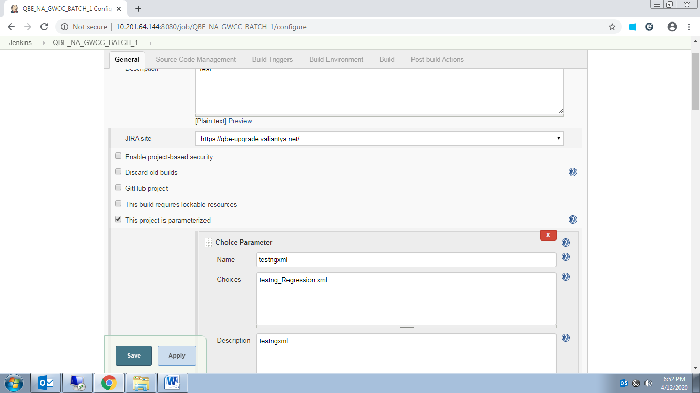

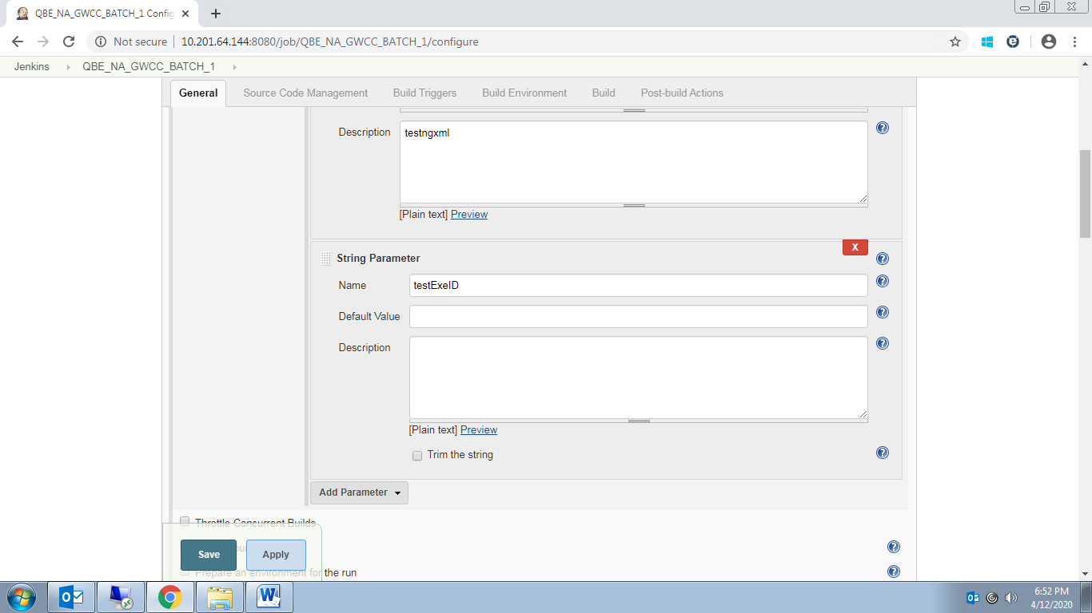

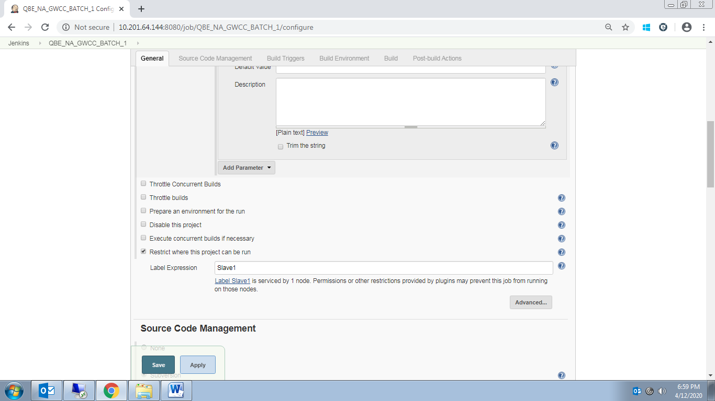

**Source Code management:**

1. Select SVN or Git
2. Give your Repository url
3. Give your credntails for accessing repository(if have)

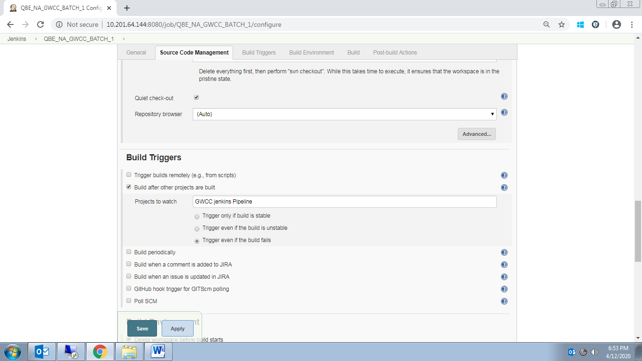

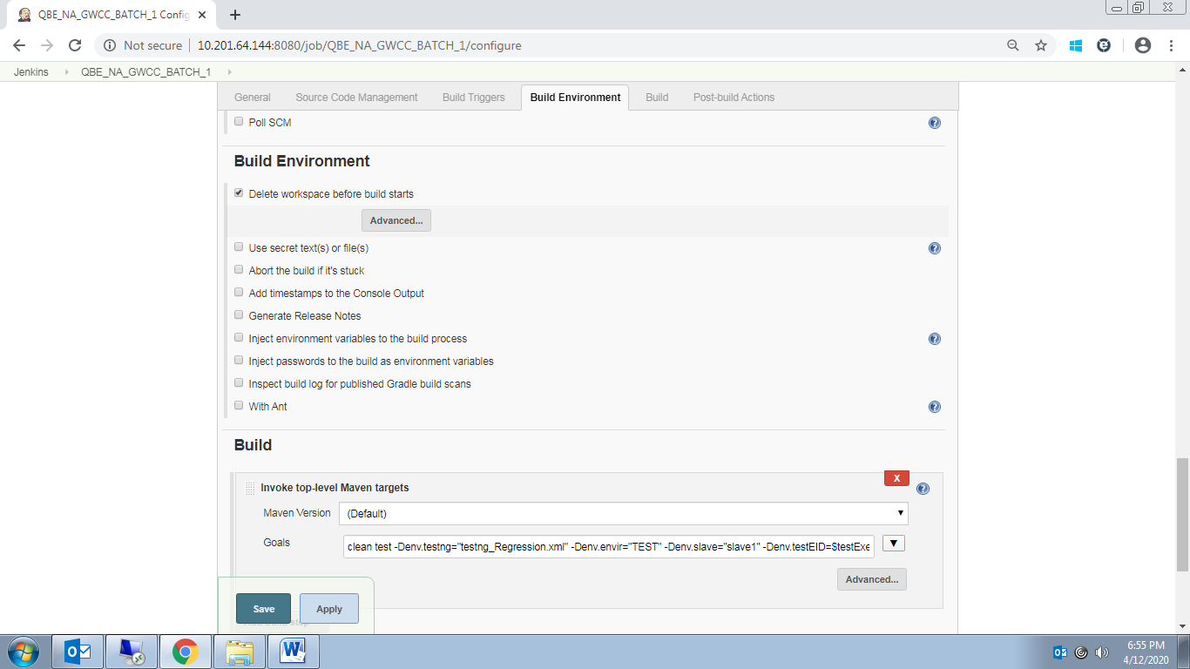

Goals

clean test -Denv.testng="testng_Regression.xml" -Denv.envir="TEST" -Denv.slave="slave1" -Denv.testEID=$testExeID